Task-1

# PROBLEM SPECIFICATION:

1.Problem definition and design thinking

# PROBLEM DEFINITION:

**our project is school management application. and our problem statement is if an institution has various branches, it cannot be easy to handle the information of student. it makes take time to login into separate application for making or maintaining the student profile with their marks**

# DESIGN THINKING

1.Empathize

2.Define the problem statement

3.Brainstorm the ideas

4.idea finalization

# Link:

<https://app.mural.co/t/schoolmanagement1121/m/schoolmanagement1121/1697946579851/72942bbe3d0b4c8c0c2328e6345d5901acb71afc?sender=u33503b8f41bce10501a38514>

# 1. Empathize

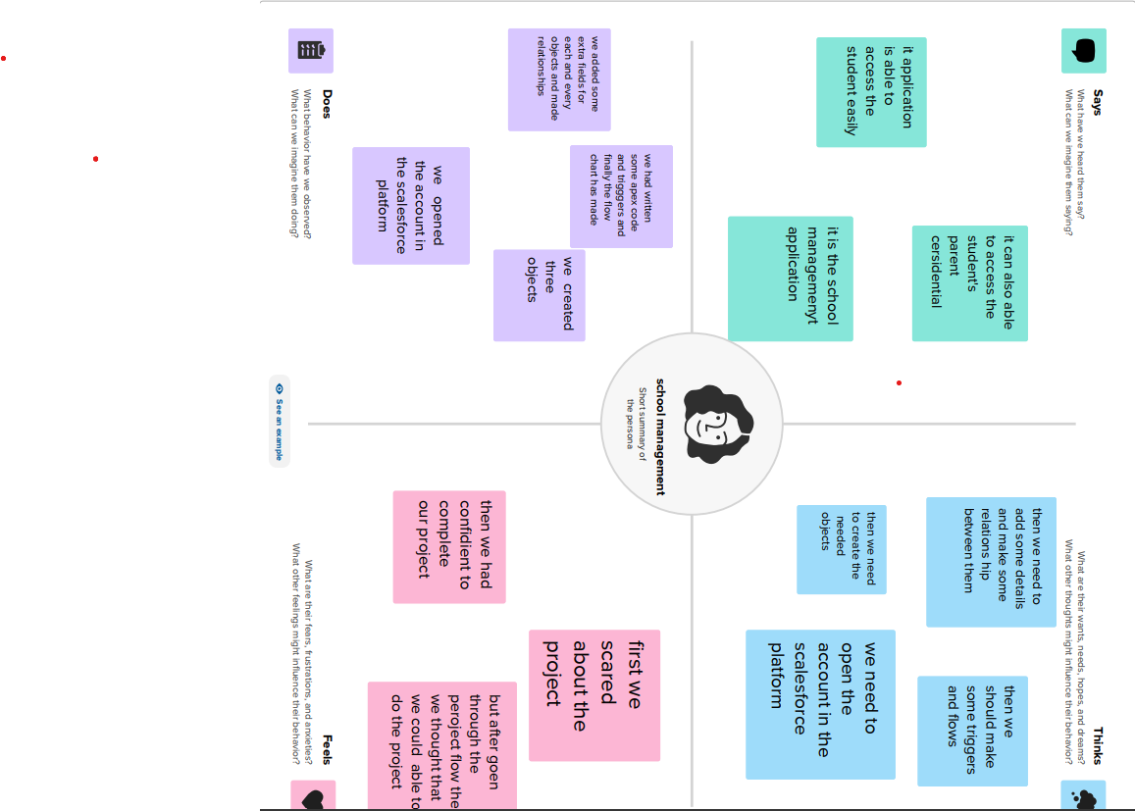

# 2.Brainstorming

1. Define the problem statement

2.Brainstorm the ideas and idea finalization

